|  |  |
| --- | --- |
| **Name** | **Mohamed Gamal Mahfouz Mohamed** |
| **B.N** | **480** |
| **Topic** | **DataBase Systems** |
| **Github link** |  |
| **Github page** |  |

# **Application brief:**

**Hello**

**I chose this topic which is very important this days its about DB and I inserted tables list ordered and unordered and images and low CSS to center the images**

**I hope I could match this topic as possible as.**

# **Screenshots:**

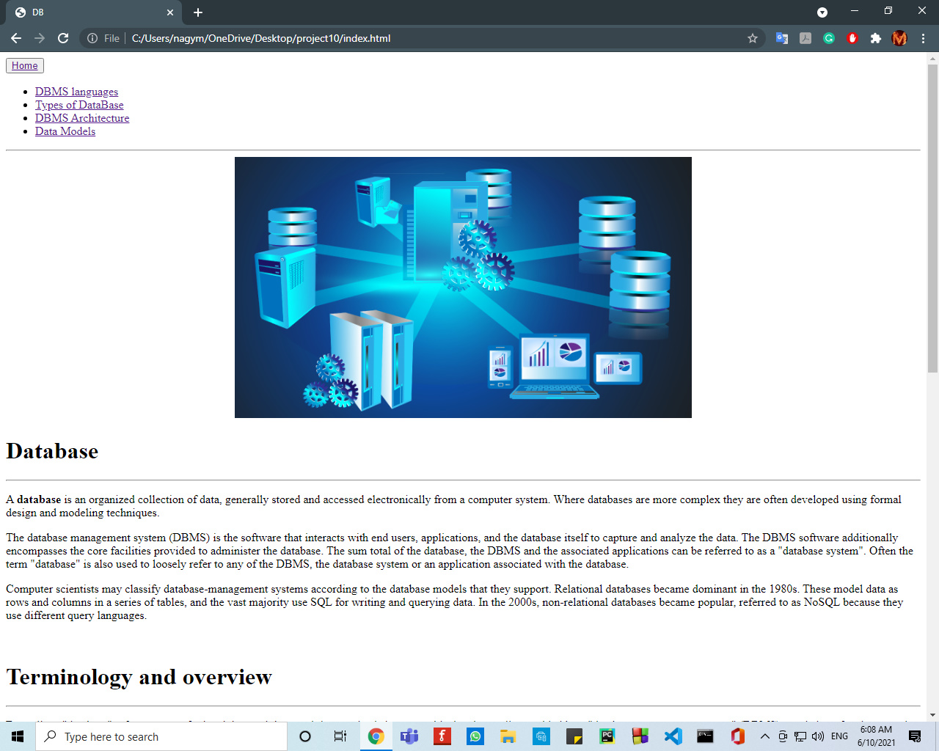

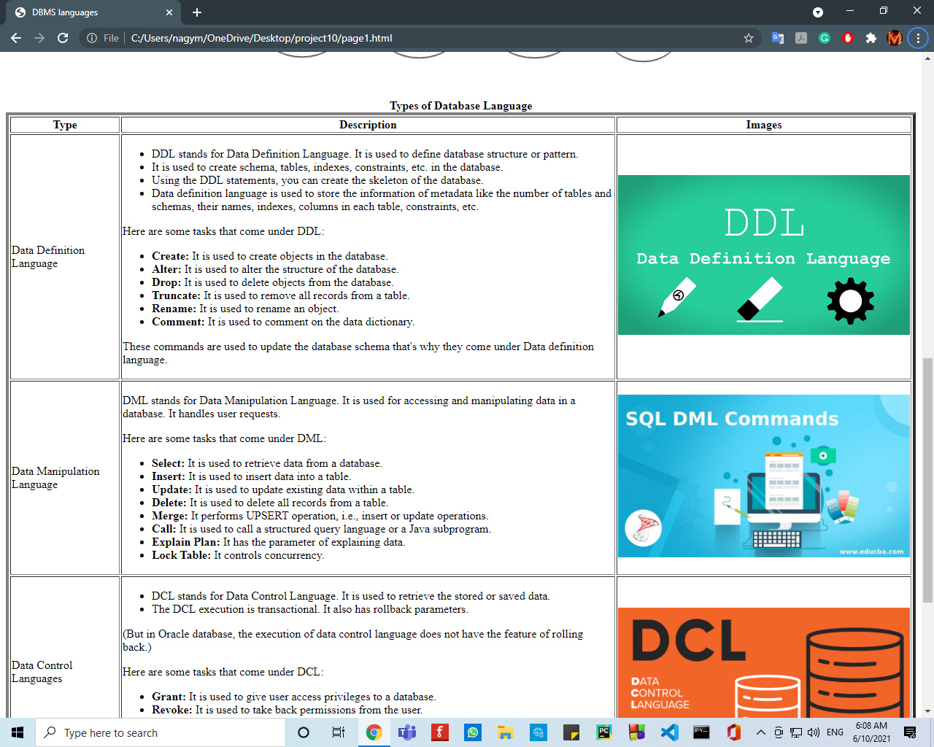

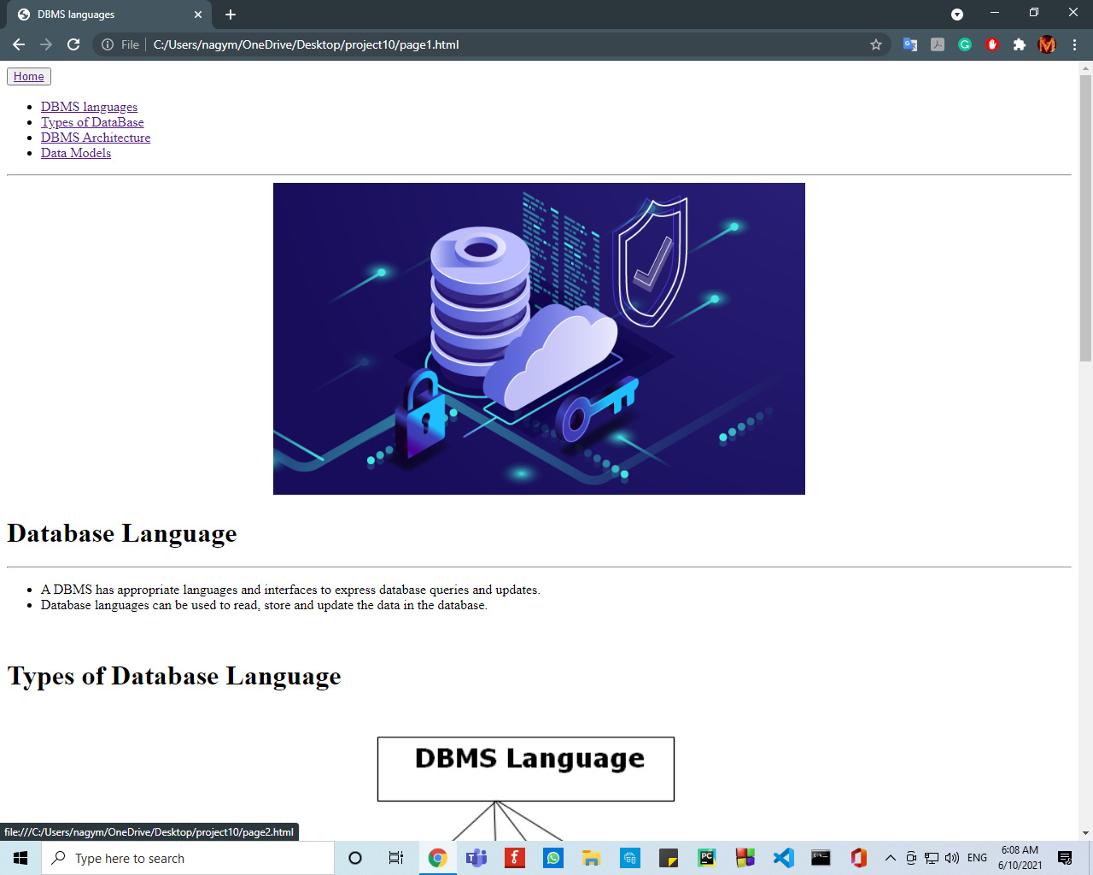

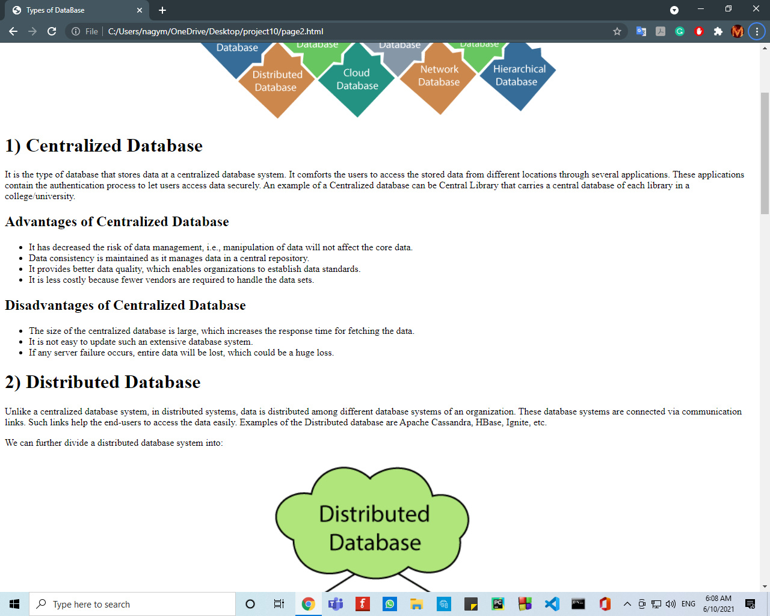

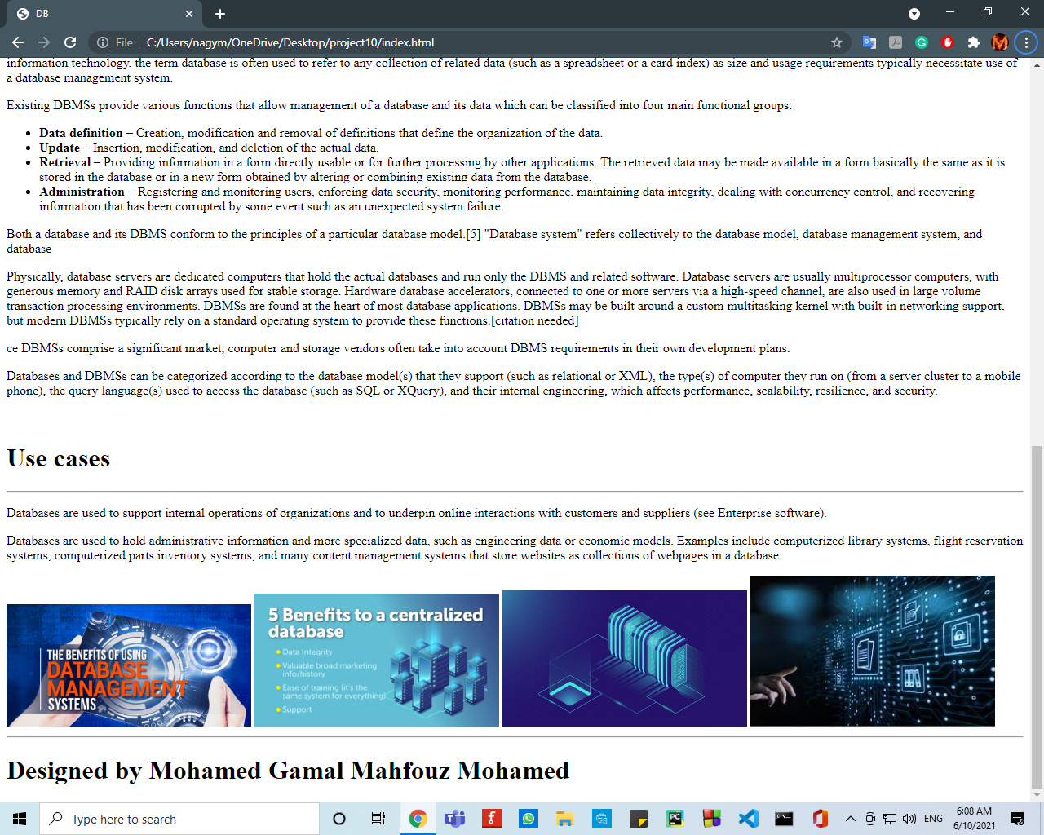

# **Source:**

